User manual for FLIMage!

# FLIMage! Window

This is the main window to control FLIM image acquisition.

## Image sequence

### Frames

Frames are acquired continuously in a single sequence with an interval defined by the scanning speed. For example, if scanning speed is 2 ms per line and 128 lines per frame, frames are acquired every 256 ms. Shutter does not close in between frames.

You can average frames to increase the signal to noise ratio (Put a value > 1 in #Average box and check “Ave” check box). If averaging on/off is different for different channels, images from different channels are saved in different file.

The textbox below “Ave” checkbox indicates the number of averaged frame (Number of frames / #average). You can edit either the averaged frame or total number of frames, and the other value will be automatically changed.

Current frame displays the progress of display, which maybe delayed from actual acquisition.

“Saved frames/slices” displays the progress of file saving.

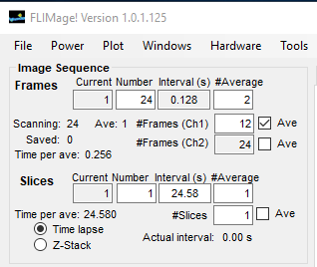

Number of slices / #average

Interval * #average

Number of frames / #average

### Slices

Slices are a set of frames (see above). Image acquisition is stopped after each “frames” acquisition. You can set an interval time, but the interval has to be longer than the total “frame” acquisition (if you set shorter time, it is automatically updated to a longer time). You can also average slices.

You can average multiple slices in the “Time lapse” mode. To do so, put a value > 1 in #Average box and check “Ave” check box.

All frames and slices are saved in one file.

If you choose “Z-Stack”, motor will move one step (step size defined in “Z-stack” panel) between slices. Again, only 1 averaged frame is allowed per 1 slice in Z-stack acquisition.

## Time lapse / Z-stack

This will change the mode of image acquisition. See above.

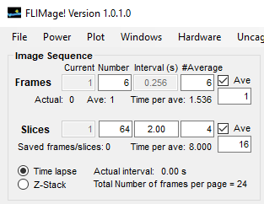

## Loop image sequences

You can loop the above image sequence. Set number of images you want to acquire and intervals of the sequence. Images are saved in different files.

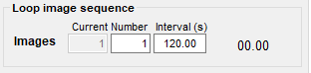

(default) Back to center position after each acquisition. When checked, adjust focus to the center of the z-stack. Program automatically moves to the start position before each acquisition.

## Z-stack

This panel allows you to set the number of slices and steps for Z stack.

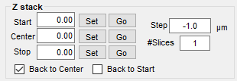

Back to home position after each acquisition

## Stage

This controls MP-285 motor stage. It continuously read the position. To change the speed of the motion, press arrow keys in “velocity” panel.

Reset button will try to recover the communication. Often you have to restart MP-285 before pressing this.

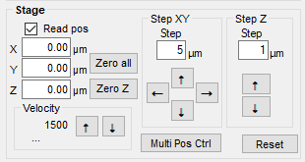

## Managing multiple motor position

By clicking the “Stage Control” menu in the “Tools” panel, you can manage multiple stage position using “Stage Position Control” window (see below). By clicking “Add position”, it will create a button (“Go Position-1”). You can create as many buttons as you want, and then go back to the position by clicking the button. To remove specific position, use “Position” pulldown to select one, and press remove.

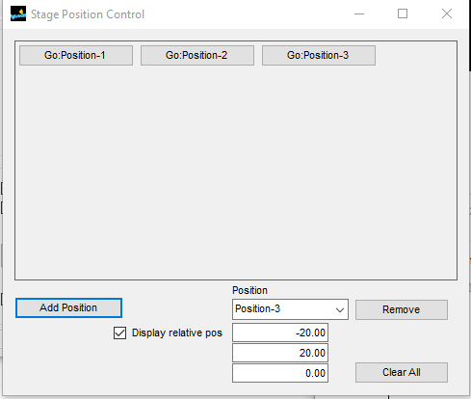

## Next file

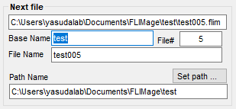The file name will be defined as:

(Base Name) (3 digit File number).flim

For example, if you put “Experimetn_1A” as the base name, the first imaged will be save in:

Experimetn_1A001.flim

The file number will automatically increase by 1 after finishing each image sequence. The next image will be saved in:

Experimetn_1A002.flim

You need to set the save path by pressing “save path…” button.

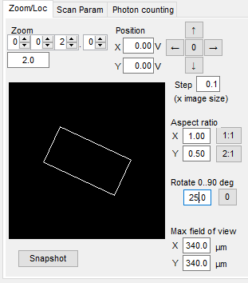

## Zoom/Loc tab

This panel controls the scan area. If you set Zoom = 1, the microscope scans the largest area. The value will be anti-proportional to the scan length (Zoom = 3 means it scans 1/3 length). The relative location of scanning is displayed in the panel.

Aspect ratio, rotation, and field of view size can be set here too.

To measure the field of view, image an object, move the object from the top to bottom, while reading the motor position (assume that the motor is calibrated).

Pressing “Snapshot” button will acquire an image with zoom 1 and display it in the panel.

## Scan Param tab

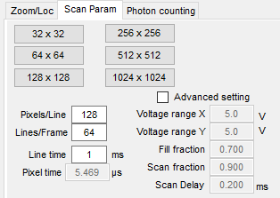The tab controls various parameters of laser scanning. Line time should be larger than ~1 ms for regular scanning. Number of lines per frame and number of pixels per line can be set in this panel.

In addition, scan voltage range, scan fraction, fill fraction and scan delay of the scanning for the fast scanning axis can be set (**Figure 1**). Scan fraction defined the fraction of forward scanning period. Fill fraction is the fraction that image acquisition occurs. You should use a range in which the mirror motion is relatively linear. The scan delay is the delay of actual mirror motion from the applied voltage. Typically, one can use 0.2 ms for scan delay, ~0.9 for scan fraction, and ~0.8 for fill fraction. If image is significantly deformed, “advanced” check box should be checked and tweak these values.

Mirror movement

Voltage applied

Fill fraction

Scan delay

Scan fraction

Voltage range

**Figure 1: Schematic illustration of command voltage (blue) and actual mirror motion (red).**

## Photon counting tab

This set the parameters for TCSPC boards (up to two boards).

Sync threshold: it sets the threshold for laser pulse detection. It should be set to a value between -50 and -200 mV for typical photo-diode output from a laser company. TCSPC boards typically require negative pulses. If necessary, put pulse inverter. Change the value until the sync pulse rate becomes robust against small shifts in the threshold, and it indicates a value similar the laser pulse rate (~80 MHz for typical Ti:Sa laser).

Channel1 and Channel2 thresholds are for photo-detection. It is typically -2 to -6 mV for un-amplified photo-multiplier tubes. Again, you need negative voltages for these inputs. The value should be modified until the photon count is stable against small shifts in the threshold. Also, if you observe a wavy pattern in the fluorescence lifetime curve, changing the threshold sometimes solves the issue.

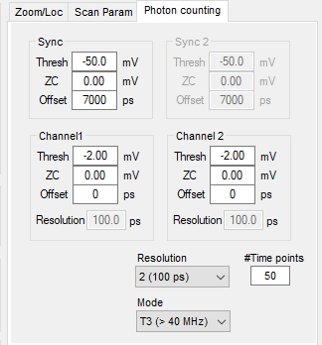ZC-level sets the values for zero-crossing voltage for peak-detection. It can be usually zero, but sometimes improving the quality of fluorescence lifetime curve by putting non zero values.

For Pico-Quant cards, it is possible to shift the fluorescence lifetime curve along the temporal axis.

#Time points (only a Pico-Quant card): The number of fluorescence lifetime time points to be acquired.

Resolution: Temporal resolution of fluorescence lifetime acquisition. Typically 100-200 ps for FLIM.

Mode: For a PicoQuant card, T3 mode is used for a high repetition rate laser (> 40 MHz). For a low rate laser (for 3 photon, for example), you may need to use T2. This is experimental feature for now.

## Channels tab

To choose channels to acquire intensity / FLIM, you can use this tab. To save memory, you can disable acquisition for the channels that are not used.

## Laser panel

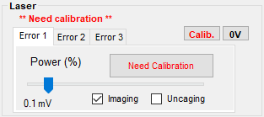This panels allows you to change the laser intensity by modeling Pockel’s cells. The software automatically calibrates it when it starts, but you should calibrate it if necessary (press “calib” button). If the laser is used for imaging, check “imaging” checkbox. If uncaging, check “uncaging” checkbox”. For a FRAP experiments etc, you can put both “imaging” and “uncaging”.

When calibration is necessary, it will indicate like follows:

## Acquisition panel

Focus: Pressing this button will start image acquisition without saving images. It should be used to focus on sample.

Grab: Pressing this button will start image acquisition and save images.

FLIM checkbox: If checked, fluorescence lifetime images will be captured.

Uncaging imaging checkbox: if checked, uncaging will run while image is acquired (only during “Grab”).

Remember setup after each acquisition checkbox: if checked, “Focus” or “Grab” operation will save the current setting.

Analyze after each acquisition: The software will analyze the data after each acquisition.

Laser needs to be pulsed for data acquisition: so, if the software does not detect the correct laser pulse rate, it will warn you as follows.

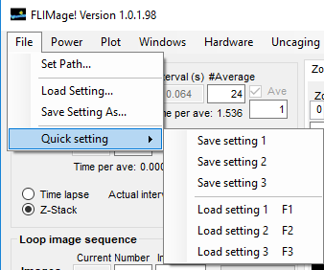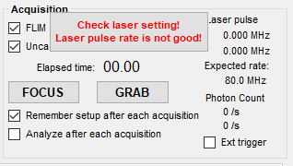

If you want to start software with an external trigger, check “Ext trigger” checkbox. External port can be set in menubar “Hardware” 🡪 “Hardware config”, and External trigger input. The same port need to be connected to the trigger source for all boards (“PFI2” is the default). Internal trigger is on “PFI6” and initiated by “port0/line0”.

If one want to send trigger to external devices, connect port0/line0 to the trigger source.

## Saving setup

To save current setup, click on “File” menu and then “Save setting as…”.

## Loading saved setup

To load saved setup, click on “File” menu and then “Load setting…”.

## Quick setting

You can save multiple setting 1-3, and quickly change your setting by pressing F1, F2 or F3.

## Setting up uncaging protocol

Click on “Tools” menu and then “uncaging control”. Uncaging location will be displayed as “+” on the “image display” window.

Uncaging panel will appear as follows:

When this panel is open, “image display” window will indicate the location of uncaging with “+” marker. You can change the location by clicking on the image. You can also memorize the position by right click on the “+” and click “Create Uncaging Location” (see below).

## 

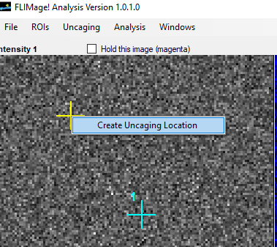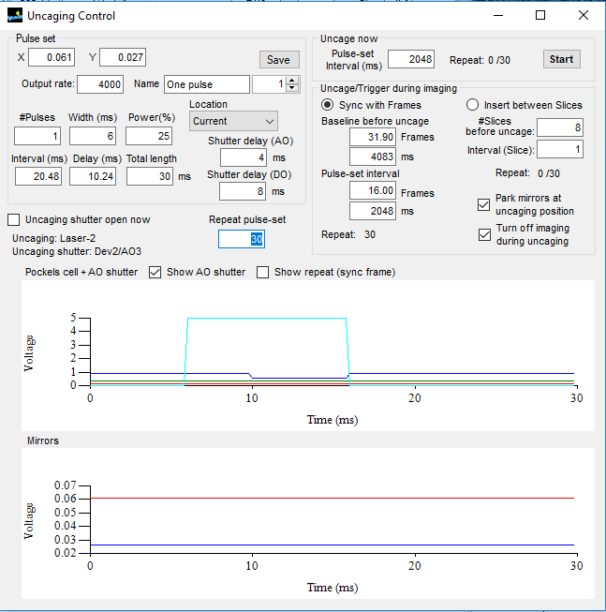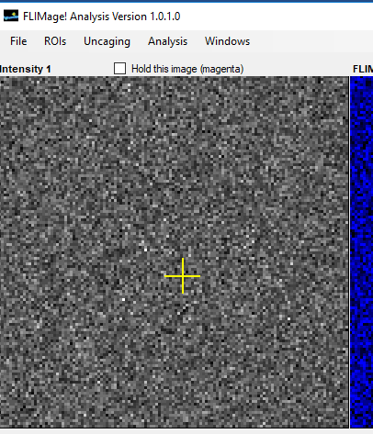

In Uncaging Control, X and Y positions indicates the current uncaging location (Yellow cross in the image). You can set pulse numbers, width, power, interval, delay etc. Because shutter can be delayed from actual command, you can set the time shutter opening command occurs (shutter delay).

If you just want to uncage, simply press “Start” in the “Uncage now” panel. It will repeat with the interval of the time indicated in the panel. In the following case, it will run the protocol 30 times with 2048 ms intervals.

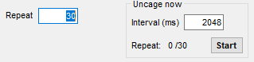

Digital port can be also used for shutter control. Set this up in “Hardware Control” menu. It can be set up for PMT shutter control (reversed polarity).

## Handling multiple uncaging locations

If you have multiple uncaging locations, you can choose which one you want to use.

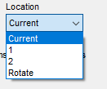

In addition, “Rotate” means that, if you have multiple pulses, the uncaging location will be changed after every pulse. You can see in the following panel that the mirror position (second graph) changes right after the first pulse to the second position.

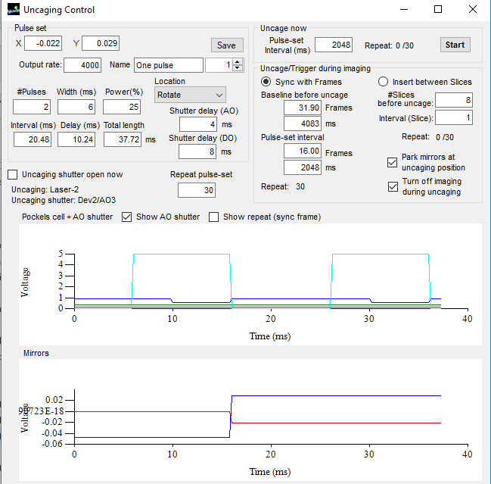

## Uncaging while imaging

If you want to uncage during imaging, you can check “uncaging while imaging” in the “FLIMage!” panel, and run “Grab”. You can either sync with frames or slices (In the time lapse mode).

### Syncing with slices (former “Page” program)

When syncing with slices, uncaging protocol is inserted between slices. If slices are acquired every 2 sec, the setting in the following panel will take 8 slices (16 s) of background and then repeat 30 times with the interval of 2 sec (1 slice). In this case, these numbers need to be integer.

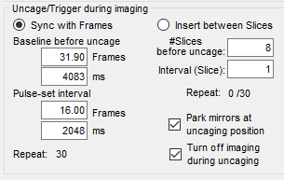

### Syncing with frames

You can also sync uncaging with frames. In this case, scanning will stop during the uncaging and uncaging protocol will run. In this case, it will run together with uncaging for every acquisition if “uncaging while imaging” is checked. The time indicated in “Sync with Frames” panel (see above) is in the unit of “Frame” or “ms” (For example, if 256 ms / frame, the time is divided by 256).

It will repeat the pulse set with the indicated frame / ms. Check “show repeat” checkbox to see the repeated version of pulses.

## Calibration of uncaging location (in Uncaging control panel)

The uncaging laser and imaging laser should be aligned, but to adjust the difference between the location of these lasers, you can use uncaging calibration panel. This can be opened by clicking on “uncaging” menu and then “Uncaging position calibration”.

You can image a fluorescence plate and bleach a spot using an uncaging protocol. If the “+” location and the beached spot is not matched, you need to calibrate the location.

To do so, you can bleach the plate first at a location (yellow +), and then right-click on the center of the bleaching spot (indicated in orange). Repeat until the location of “+” matches to the bleaching spot. Then, press “Apply” button. If the values are larger than 0.1V, you may want to manually put zero and redo this process again.

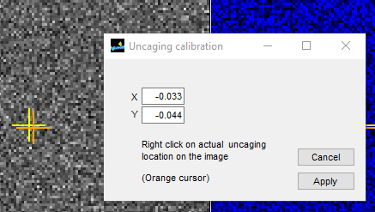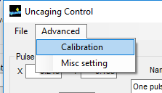

## Hardware config (Hardware 🡪 Config)

This facilitates the setting of hardware. It should be self-exoplanetary. Don’t touch this unless you understand the system.

# Image display window

This window is to display and analyze acquired images.

## Opening file

Click on “File” menu 🡪 “Open FLIM image” (or control – O). If the base name and the folder path is the same, you can open the previous or next image by clicking “<” or “>” buttons on the “file” panel under the images, respectively (see below). For a large file, you may want to stop opening by clicking “Stop opening” button on the “File” panel.

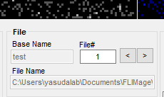

## Folder path for analyzed data

All analyzed data will be save in the current folder, the folder in which FLIM images are saved. The software creates subfolders called “Intensity”, “FLIM” and “Analysis” when necessary. All analyzed data are saved in Comma-separated values format, and can be read via Excel and most of other software.

## Export tiff images

Click on “File” menu 🡪 “Export formatted images (TIF)”. This exports intensity and FLIM images on the display in folders “Intensity” and “FLIM” in the current folder path. Different channels are saved in different files (_ch1 and _ch2), if you check “Channels in separted files” checkbox (right bottom of “FLIMage analysis” window).

If you click on “File” 🡪 “Batch processing (Export images & analysis)”, it will analyze and export processed images for the files under the same base name (XXX001, XXX002 etc).

## Viewing image setting

Click on “File” menu 🡪 “Show image description” to see image information (see right). If you want more detailed list, press control (maybe not readable).

## Display uncaging location On/Off

Click on “Uncaging” menu 🡪 “Show uncaging position”.

## Max or sum projection

You can check “projection” checkbox in the “Frames / Slices” panel to display projection.

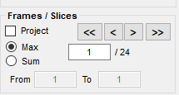

### Frames/Slices navigation

You can navigate slices or frames by clicking “<” or “>” in “Frames / Slices” panel (see above). “<<” and “>>” is moving 10 frames/slices.

## Region of interest

Click on the image and drag to the left bottom. You can draw a region of interest (ROI). You can choose to create a shape of either rectangular, circular or polygonal. Use the toolbox above the images (red circle in the following figure).

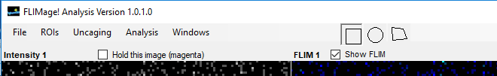

The created ROI is called “selected ROI” and displayed in red. If you right-click onto the ROI, you can create one of “multi ROIs”, which is indicated in cyan.

Double clicking on the window will delete the “selected ROI”. To delete a multi-ROI, right click on the ROI you want to delete, and follow the instruction.

To delete all multi-ROIs, right-click on the window outside of ROIs and choose “Remove All Rois” in the pulldown menu.

### Saving ROIs

To save multi-ROIs, click “ROIs” menu and then click “Save ROIs”. This will save ROIs in {Current path}/Analysis. To recover multi-ROIs, click “Recover ROIs” in the “ROIs” menu. Saving/Reading ImageJ style ROIs is possible (in ROIOs menu).

## Fluorescence lifetime curve and fitting

Fluorescence lifetime curve is displayed in the right panel. The curve is displayed from red ROI (selected ROI). If you choose to show multi ROIs, it will display all pixels in the multi ROIs. You can choose to select individual multi ROI.

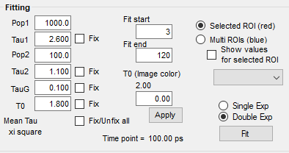It should be noted that black pixels (pixels with intensity values under the lower threshold) will be NOT included in the curve. This is because low-photon pixels often include little information but a lot of noise.

Fitting will be performed either on selected ROI or all multi ROIs (you can select with radio buttons on the “Fitting” panel.

“Fit start” and “Fit end” defines the fitting range (in time point). Also, the lifetime window will display only this range.

Fitting will be performed with Gaussian instrument response function (width = tauG) convoluted with exponential curve. You can choose to fit with double- or mono-exponential curves (decay constants = tau1 and tau2, populations pop1 and po2). Time offset (T0) will be also fitted.

Fitting will be performed when you click “Fit” button. At the same time, it will save all parameters in “Analysis” folder in the current folder path.

You can fix any of these parameters.

The fitting function is defined as follows.

For single exponential curve:

y1 = pop1 * Exp(tauG^2 / tau1^2 / 2 - (x - t0) / tau1);

y2 = Erfc((tauG^2 / tau1 - (x - t0)) / (Sqrt(2) * tauG));

exp_gauss(x) = y1 * y2 / 2;

We usually add fluorescence lifetime decay from 1 pulse before:

exp_gaus_corrected (x) = exp_gaus(x) + exp_gaus(x-IPI),

where IPI is the iter-pulse interval (for 80 MHz, it is ~12.5 ns).

For double exponential curve:

y = pop1 * exp_gauss_ corrected (x, tau1) + pop2 * exp_gaus_corrected (x, tau2)

## FLIM colormap image

To correctly display colormap, you need to fit the fluorescence lifetime curve and then apply time offset (T0) by clicking “apply” button.

## Correcting drift for images

Analysis 🡪 Align pages will align image pages within the same image. For series of images (like XXX001.flim, XXX002.flim etc), use Analysis 🡪 Make Movie from Series. This will make Z-projection (Max or Sum ) for each image (if Z-stack) and align. For T-stack or any time series, it will handle each page as a single image.

To save the collected and corrected file, do File 🡪 Save FLIM Image. For ImageJ readable image stack, use File 🡪 export formatted images.

# Time course window

This window is to get time course of the time-lapsed images.

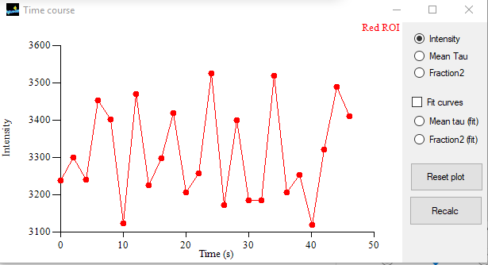

Intensity value INCLUDES black pixels. It is sum of fluorescence in the ROI.

Mean tau is defined as the average photon arrival time subtracted with time offset (T0). Black pixels (pixels with intensity values under the lower threshold) are NOT included in the curve. From the lifetime curve (time vs fluorescence) in each ROIs, it is calculated as:

Mean tau = Σi (time * fluorescence) / Σi(fluorescence) – t0,

where *i* is all pixels in the ROI and above the threshold.

Fraction2 is the fraction of tau2 population:

Fraction2 = pop2 / (pop1 + pop2).

Its approximate value can be obtained from mean tau (tau_m0) as:

Fraction2 = tau1 * (tau1 - tau_m0) / (tau1 – tau2) / (tau1 + tau2 - tau_m0).

If you click “Fit curves”, the software will fit fluorescence lifetime curves in each image. Values obtained by fitting will be stored as “Mean tau (fit)” and “Fraction2 (fit)”. Mean tau in this case is defined as:

Mean tau = (tau1^2 * pop1 + tau2^2 * pop2) / (tau1 * pop1 + tau2 * pop2).

All values are automatically saved in “Analysis” folder in Excel (csv) format.

# Using python script

In Documents\FLIMage\Python script, there are several python scripts useful for analyzing the data. These scripts run on a standard Anaconda 3 environment.

## FLIM_pipeClient.py

This is a python Class to communicate with FLIMage. See RemoteControl_Tutorial.docx for API.

## FLIM_PlotScript.py

This is an example script that uses FLIMageFileReader.py to open '*.flim' images created by FLIMage, calculate lifetime and plot.

## FLIMageFileReader.py

This is a python class that provides fucntion to read files (like ‘*.flim’ or ‘*.tif’ created by FLIMage! software. It also include function to calculate lifetime, intensity and lifetime map. Detailed parameters are stored in FileReader.State.

This script requires libtiff package. Although anaconda includes this package, you need to run ‘pip’ to setup the environment:

>> pip install libtiff

in a shell programs with python path included (for example, ‘anaconda prompt’ software can do this).

## ReadFLIMageCSV.py

This is a python class that provides functions to read and average all time course files (.csv files) in a directory.

## ReadFLIMageCSVGUI.py

This program is a GUI backend for ReadFLIMageCSV program.